**Software Requirements Specification**

**for**

**IM-SCHOOL**

**Version 1.0 approved**

**Prepared by /**

**Mohammed Gamal Mahmoud Ahmed**

**Islam Ashraf Nour Elden**

**1 / 4 / 2020**

**Table of Contents**

**Table of Contents ii**

**Revision History ii**

**1. Introduction 1**

1.1 Purpose

1.2 Document Conventions

1.3 Intended Audience and Reading Suggestions

1.4 Product Scope

1.5 References

**2. Overall Description 2**

2.1 Product Perspective

2.2 Product Functions

2.3 User Classes and Characteristics

2.4 Operating Environment

2.5 Design and Implementation Constraints

2.6 User Documentation

2.7 Assumptions and Dependencies

**3. External Interface Requirements 3**

3.1 User Interfaces

3.2 Hardware Interfaces

3.3 Software Interfaces

3.4 Communications Interfaces

**4. System Features 4**

4.1 System Feature

4.2 System Feature

**5. Other Nonfunctional Requirements 4**

5.1 Performance Requirements

5.2 Safety Requirements

5.3 Security Requirements

5.4 Software Quality Attributes

5.5 Business Rules

**6. Other Requirements 5**

**Appendix A: Glossary 5**

**Appendix B: Analysis Models 5**

**Appendix C: To Be Determined List 6**

**Revision History**

|  |  |  |  |
| --- | --- | --- | --- |
| **Name** | **Date** | **Reason For Changes** | **Version** |
|  |  |  |  |
|  |  |  |  |

**1. Introduction**

**1.1 Purpose**

The e-Exam is an electronic test taken individually by the students in the e-Exam room. Students notified with their e-Exam time and each question has limited time, when time of exam out, the exam will be submitted automatically.

Due to usability concerns, the e-Exam must not be the only way to complete a course, for example. See Accessibility Info.

E-Exam is available in Arabic, English and after you've signed in you can change the user interface language.

The goal of the e-Exam is to encourage more flexible examination practices, which are part of the broader University stratum

**1.2 Document Conventions**

Fonts: Times, Arial.

**1.3 Intended Audience and Reading Suggestions**

* Student
* Project Owner
* Developer
* Tester
* Software Engineer

**1.4 Product Scope**

E-Exam is intented only to students to take their exams online

**1.5 References**

**2. Overall Description**

**2.1 Product Perspective**

E-Exam was developed for students to take their exam online.

It is an open source project and it has a very active developer team to support

it and provide feedback to users. It was developed to run on Windows.

**2.2 Product Functions**

**Admin Functions:**

* Login
* Accept students’ and professors’ requests
* View Students
* View professors
* Add & view levels
* Add & view departments
* Add & view subjects
* Logout

**Student Functions:**

* Login
* Take exam
* Take training exam
* View question bank
* View results
* Logout

**Professor** **Functions:**

* Login
* Add & view chapters
* Add & view questions
* View students’ results
* Add exam
* Logout

# 2.3 User Classes and Characteristics

* Typical Users, such as students, who want to use e-exam to pass their exam
* Advanced/Professional Users such as professors
* Developers who are interested in working on the project by further developing it or fix existing bugs

# 2.4 Operating Environment

* Windows 2000 Windows XP
* Windows Vista
* Windows 7
* Windows 8
* Windows 10

# 2.5 Design and Implementation Constraints

* UML
* PHP & Ajax
* MySQL & Xampp Database

# 2.6 User Documentation

E-Exam provide users guide about how to start their exam.

It also provides online help about how to use software.

**2.7 Assumptions and Dependencies**

E-Exam is developed in PHP and therefore requires PHP to be installed on

the user’s system. This applies to Windows and Linux users. On Mac OS X,

PHP is bundles with the application.

**3. External Interface Requirements**

**3.1 User Interfaces**

Student must login to access system features

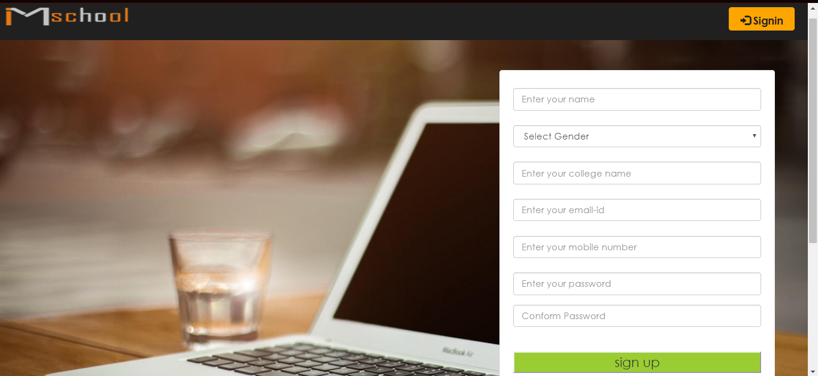

He can view question bank that enable him to pass his exam

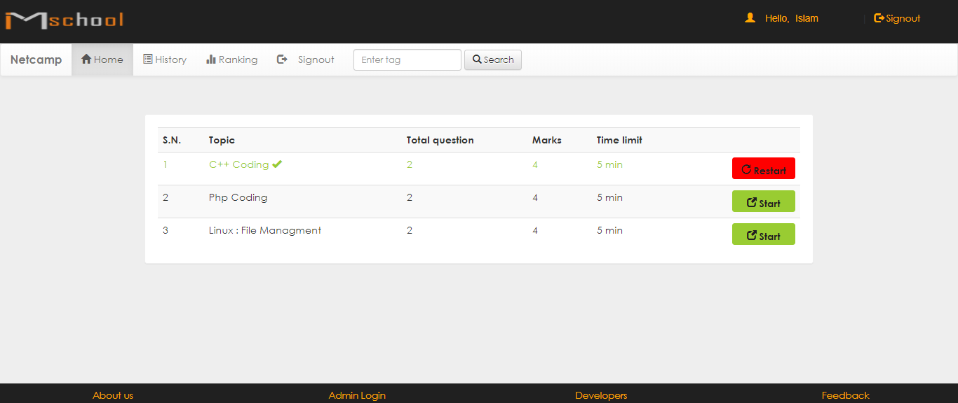

Student’ exam

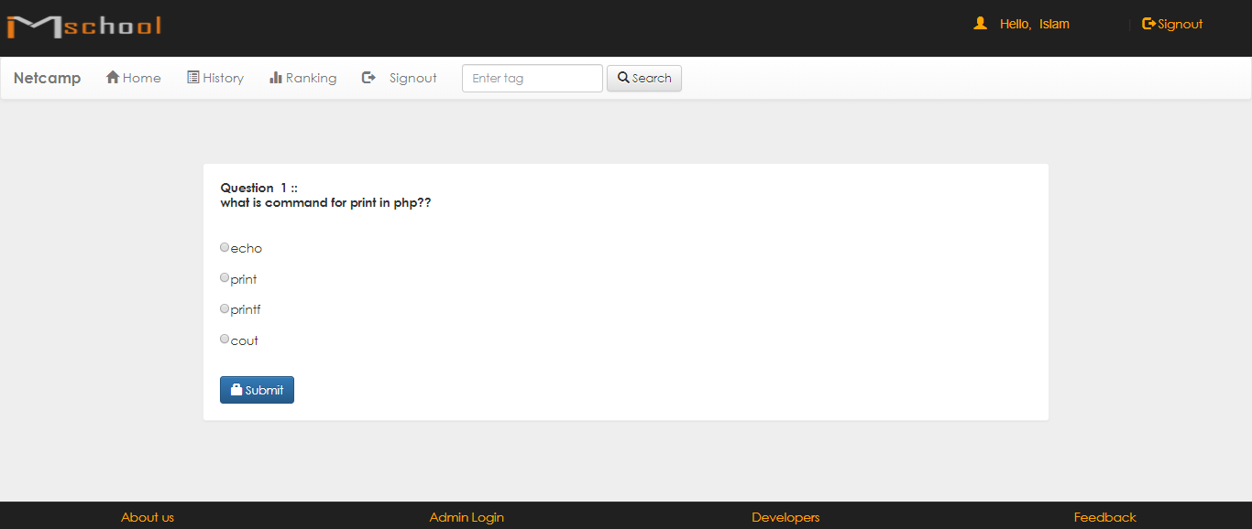

Student’ results interface

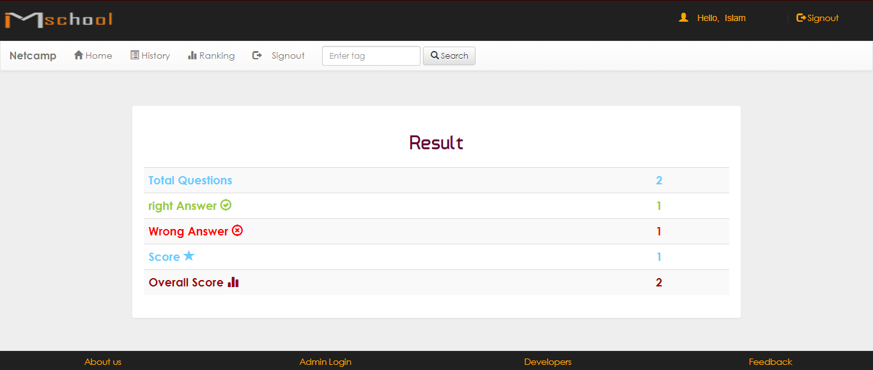

**3.2 Hardware Interfaces**

The minimum hardware requirements of IM-SCHOOL

* CPU: 500mhz
* RAM: 128GB
* MONITOR
* MOUSE

**3.3 Software Interfaces**

* PHP
* MYSQL
* LOCALHOST

**3.4 Communications Interfaces**

IM-SCHOOL require connection with internet to install new version, update already update some of its components (APIs, modules etc.).

**4. System Features**

This section demonstrates IM-SCHOOL’s most prominent features and explains how they can be used and the results they will give back to the user.

**4.1. Access exam:** students can access exam from any where that help to make it easy, low-cost and save time

**4.2. Question Bank:** IM-SCHOLL provide students with many questions from which professor selects exam questions

**4.3. Training Exam:** students can take test exam that gives them full background of real exam

**5. Other Nonfunctional Requirements**

**5.1 Performance Requirements**

Performance will be low somewhat because students will access exam at the same time

**5.2 Safety Requirements**

To ensure that no one of e-Exam’s users loses any data while using e-Exam’s (due to a crash or a bug of some kind) the developer team updates e-Exam’s regularly. There is a bug tracker available where users can report any bugs they have encountered so that the developers can fix it in the next release.

**5.3 Security Requirements**

Secure electronic exams are one of the most challenging security issues in e-learning. For any academic institution, the importance of the examination cycle means that various protection measures must be implemented to maintain certain protection property at different examination stages. In this paper we present a safe e-exam management framework in which all the information relevant to the test is in digital format. We are proposing a cryptographic scheme to be implemented in order to attain the required degree of security at each examination point.

**5.4 Software Quality Attributes**

IM-school provides the users with both simple and advanced features. Due to its well designed and easy to use interface it can be used by both experts and typical users.

However, users must already have a basic knowledge of graphs before using it.